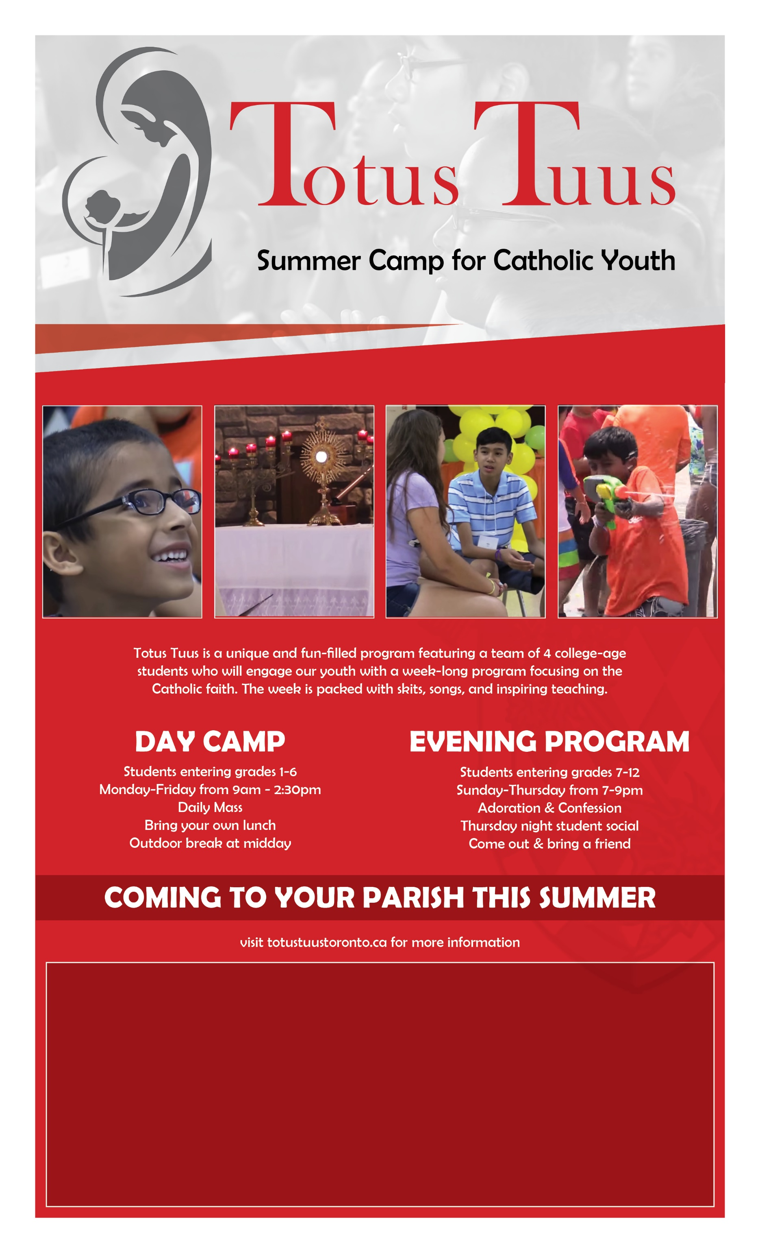

Totus Tuus for St. Ann’s Parish will take place on: July 9-14, 2017

To register and for more information
please contact us at the St. Ann’s Office 705-549 2560

